UNIT-III

OPERATIONS ON SPLAY TREES
  - All the operations on splay trees can be performed in the same way as in case of an ordinary Binary Search Tree except that, every operation is followed by splaying.
- Search
- Insert
- Delete

- SEARCH
The last node accessed during the search is splayed
  - If the search is successful, then the node that is found is splayed and becomes the new root.
  - If the search is unsuccessful, the last node accessed prior to reaching the NULL pointer is splayed and becomes the new root.

Example:
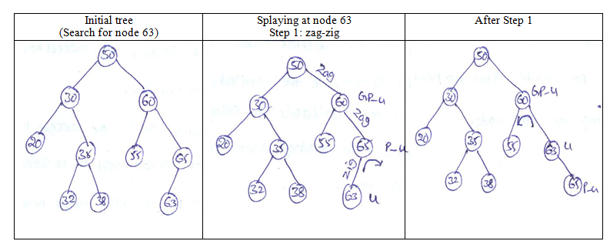

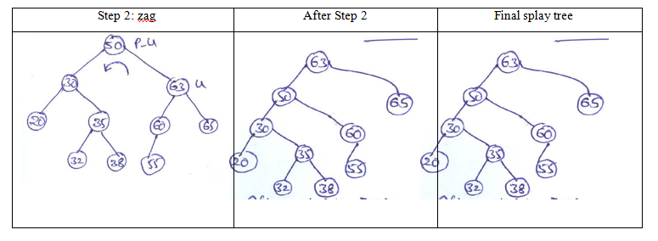
- INSERTION
When an item is inserted, a splay is performed. As a result, the newly inserted item becomes the root of the tree.
Example: Insert the node 70 into the following splay tree
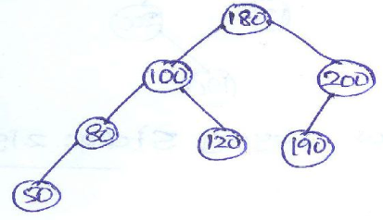
  - Here node to be inserted as Right child to node 50
  - Here node 70 becomes access node.

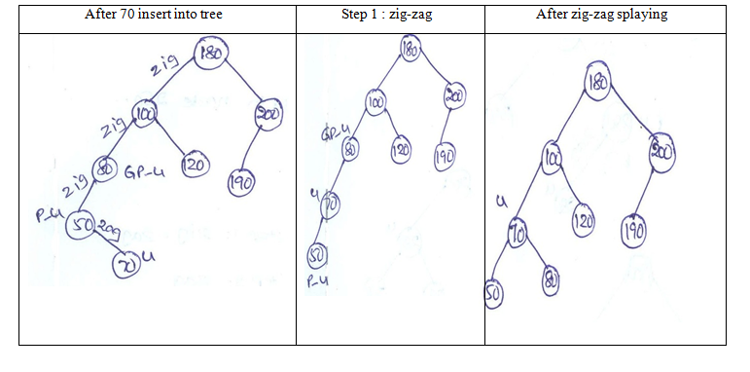
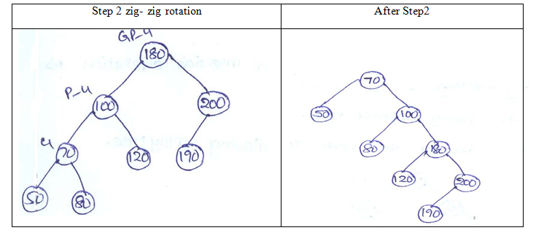

- DELETION
  - Access the node to be deleted bringing it to the root.
  - Delete the root leaving two Subtrees L (left) and R (right).
  - Find the largest element in L, thus the root of L will have no right child.
  - Make R the right child of L’s root.
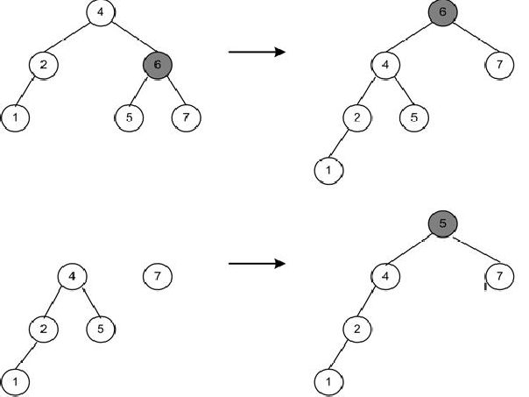
Example: Deleting 6 from the splay tree

Time complexity for various operations on Splay tree:

Operation | Average case | Worst case
Search | O(logn) | amortized O(logn)
Insertion | O(logn) | amortized O(logn)
Deletion | O(logn) | amortized O(logn)

Space Complexity : O(n)

